AD ASTRA INFANT SCHOOL
VIOLIN TEACHER

CHARLOTTE STOPPS

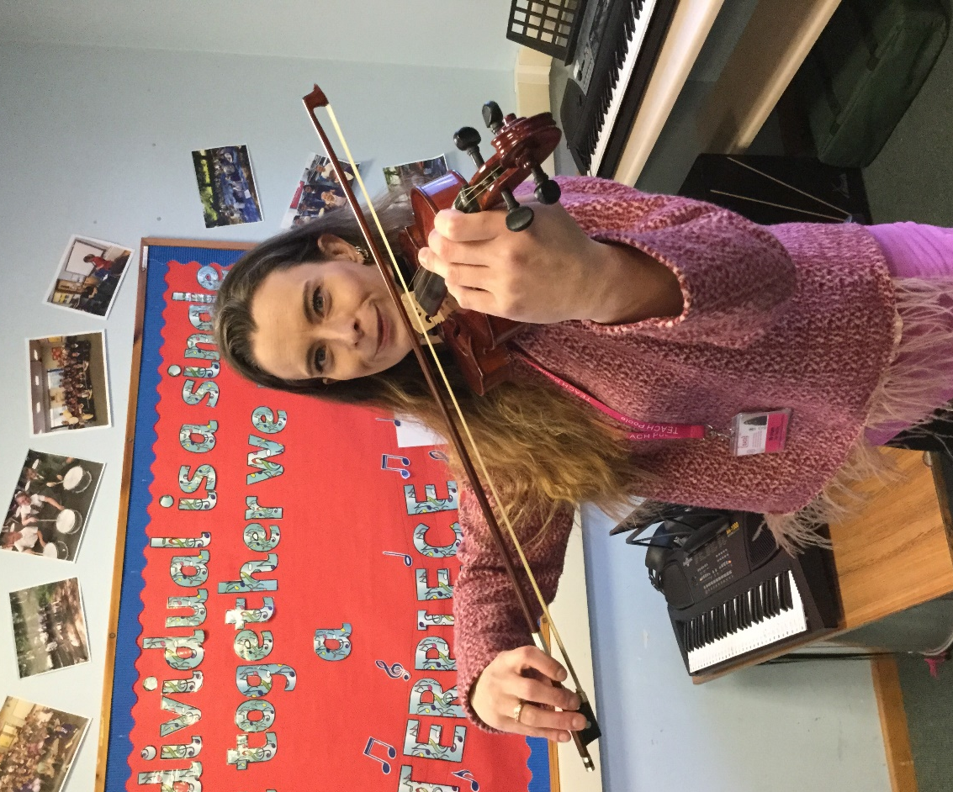

£20 for 10 lessons
20 minutes

How to contact Charlie Stopps;
07984 417207
fingersandstrings@icloud.com

