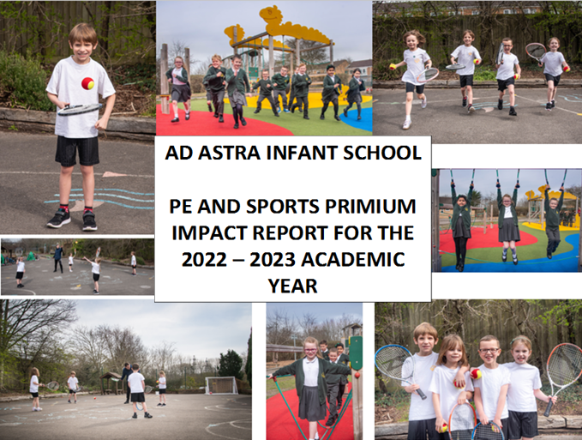
Ad Astra Infant School

PE and Sports Premium impact report for the 2023 – 2024 academic year.
Details with regard to funding
Please complete the table below.

Total amount carried over from 2021/22 | £0.00
Total amount allocated for 2022/23 | £17,800
How much (if any) do you intend to carry over from this total fund into 2023/24? | £2083
Total amount allocated for 2023/24 | £17,800
Total amount of funding for 2023/24. To be spent and reported on by 31st July 2024. | £19,883
Actual spend for 2023/24 | £20,151.68
Swimming Data
Please report on your Swimming Data below.

Meeting national curriculum requirements for swimming and water safety.  N.B. Complete this section to your best ability. For example you might have practised safe self-rescue techniques on dry land which you can then transfer to the pool when school swimming restarts.  Due to exceptional circumstances priority should be given to ensuring that pupils can perform safe self-rescue even if they do not fully meet the first two requirements of the NC programme of study | N/A – swimming takes place at our partner junior school.
What percentage of your current Year 6 cohort swim competently, confidently and proficiently over a distance of at least 25 metres?  N.B. Even though your pupils may swim in another year please report on their attainment on leaving primary school at the end of the summer term 2023.  Please see note above | N/A
What percentage of your current Year 6 cohort use a range of strokes effectively [for example, front crawl, backstroke and breaststroke]?  Please see note above | N/A
What percentage of your current Year 6 cohort perform safe self-rescue in different water-based situations? | N/A
Schools can choose to use the Primary PE and sport premium to provide additional provision for swimming but this must be for activity over and above the national curriculum requirements. Have you used it in this way? | N/A

Action Plan and Budget Tracking
Capture your intended annual spend against the 5 key indicators. Clarify the success criteria and evidence of impact that you intend to measure to evaluate for pupils today and for the future.

Key indicator 1: The engagement of all pupils in regular physical activity – Chief Medical Officers guidelines recommend that primary school pupils undertake at least 30 minutes of physical activity a day in school. |  |  |  | Spend and percentage of total spend:
 |  |  |  | £13,784.96 68.4%
Intent | Implementation |  | Impact | Sustainability and suggested next steps
- Engagement of all pupils in regular physical activity – kick-starting healthy active lifestyles.  - Pupil voice for equipment.  - Purchase robust quality lunchtime resources.  - Create more opportunities for children to be active in the playground.  - Children’s behaviour and social skills are still suffering as a result of the COVID-19 pandemic – this needs investment.  - Create more opportunities for children to be social and play together in the playground.  - Identify children who are less active.  - Teach the children how to use the playground equipment and markings to encourage them to be more active.  - Provide teachers opportunities to be more active in core lessons, such as phonics, by providing playground markings to suit these lessons. | - Purchase a range of outdoor play equipment to encourage more active and social interactions on the playground for EYFS and KS1 children.  - A range of lunchtime and afterschool clubs.  - Provide ‘play leaders’ to encourage children to participate in active lunchtimes and enable us to offer use of the climbing frames at lunchtimes.  - Sporting transition events with partner junior school for Year 2.  - Annual safety inspection of PE equipment to ensure safety of the children during PE lessons.  - Active school trips that encourage physical activity. | £8,882.96  £0  £4,242  £0  £120  £540 | - Improved activity levels, behaviour and children’s social skills.  - Less behavioral incidents being reported by staff on duty (observations of children’s behaviour has shown a large improvement).  - Children are happier and more active having a variety of things to play with.  - Higher engagement and participation in a range of physical activities.  - Enough equipment for ALL children to use when outside.  - Children have been playing together with the new equipment and can have purposeful and active social interactions with their peers.  - Children able to access a variety of sports.  - Clubs are run both inside the classroom and outside the classroom that focus on and provide good support for children’s mental wellbeing. | - More storage needed to make sure the equipment is sustained for a longer period.  - Designated areas for ball games.  - Introduction of KS1 sports leaders who lead playtime and lunchtime activities.  - All children need to be taught at the start of the year how to use the playground equipment and how to get it out and put it away to ensure it is looked after.  - Clubs planned for different times of year to make use of both outdoor and indoor environments.  - Wider range of sporting equipment that is accessible for all.
Key indicator 2: The profile of PESSPA being raised across the school as a tool for whole school improvement |  |  |  | Spend and percentage of total spend:
 |  |  |  | £4,443.50 22.1%
Intent | Implementation |  | Impact | Sustainability and suggested next steps
- Raise the profile of PE and sport across the school by developing a Growth Mindset and linking this to the TEACH Trust value of resilience.  - Provide the children chances to better understand the benefit of having a healthy lifestyle and making good, healthy life choices.  - Make it easier for staff to access equipment to enable them to use it effectively within PE and other lessons.  - EYFS need support to develop their fine and gross motor skills, which will enable them to make quicker progress throughout their school life if addressed quickly.  - Children on the SEND register often need active breaks (generally sensory-based) to help them regulate and return to class, thus making good academic and personal progress.  - PE must be fully equipped. | - After school clubs run by outside agencies (mainly Premier Sports).  - New storage facilities, alongside better organisation to make accessing PE equipment easier for both indoor PE and outdoor games.  - With discussions with the EYFS leader and the SENDCO with regard to current research, resources that can be used to support EYFS and SEND children with their learning and development were purchased.  - Ensure that all curriculum PE has the correct and appropriate equipment so that all lessons can be taught effectively and to a high quality. | £0  £435.89  £4,007.61  £0 | - Broadened and encouraged participation in varied sports.  - Quality of the provision in the EY and KS1 playgrounds are enhanced.  - Equipment is more accessible and matches scheme of learning and equipment will last longer.  - The addition of storage facilities has ensured that equipment is stored correctly, ensuring longevity of the equipment. The children are also becoming more responsible for getting it out and putting it back.  - The PE curriculum is fully equipped for all year groups.  - Children are now able to have sensory breaks with a purpose and well-thought out resources, meaning that they are able to return to the classroom quicker, and in a much better place to do their learning.  - The children in EYFS are able to develop their skills in ways that they have not been able to previously, such as developing their core strength and hand strength, which aids handwriting. | - Range of clubs (including active and sporting) provided by teachers.  - Replenish and replace boxes that need replacing, along with other storage facilities.  - Monitor stock of equipment and the needs of equipment to ensure there is enough for our intent.  - Continue to store equipment neatly and safely.  - Continue to invest in EYFS and children with SEND, adapting to the needs of the children.

Key indicator 3: Increased confidence, knowledge and skills of all staff in teaching PE and sport |  |  |  | Spend and percentage of total spend:
 |  |  |  | £1,923.22 9.5%
Intent | Implementation |  | Impact | Sustainability and suggested next steps
- Increased confidence, knowledge and skills of all staff when teaching PE and sport.  - Pupils have high quality PE lessons, delivered by confident and knowledgeable staff using high quality planning.  - Pupils are fully engaged within PE lessons and are physically active for most of it.  - Ensure that all the teachers have access to Get Set 4 PE and uses their resources. | - Continued use of the current schemes of work, with continued adaption to lesson plans and medium-term plans.  - Monitor and discuss PE provision with year leaders to ensure high quality PE is taking place.  - Renew Get Set 4 PE this year for one year.  - Continue subscription to the Youth Sport Trust.  - PE Lead to provide CPD and monitoring opportunities for members of staff. | £0  £0  £573.73  £1,349.49  £0 | - Teachers are more confident about how to effectively teach PE, using the current resources available. | - Continued adaption to lesson plans and medium-term plans to be implemented over the current academic year, especially adapting the dances into a more effective and thought-through sequence of lessons.  - Continue to adapt lessons plans where needed, focusing mainly on ways in and challenges to extend.  - Use external coaches or companies to provide CPD to teachers and HLTAs.  - Teachers to watch PE Lead teach an indoor and outdoor PE lesson.  - PE Lead to ‘team teach’ with teachers and provide feedback.
Key indicator 4: Broader experience of a range of sports and activities offered to all pupils |  |  |  | Spend and percentage of total spend:
 |  |  |  | £0 0%
Intent | Implementation |  | Impact | Sustainability and suggested next steps
- Provide broader experiences in a range of sports and activities to all pupils.  - Pupil voice for extra-curricular activities. | - Clubs – afterschool and lunchtime.  - Continued adaption to new scheme of work.  - AFCB providing secondary school readers, with their supporting adults coming in in AFCB training kit.  - Adapt and improve sports day so that all children can participate safely and enjoy their time doing it.  - Select the different playground equipment carefully when purchasing.  - Staff clubs to include different activities, including sporting ones. | £0  £0  £0  £0  £0  £0 | - Children are exposed to new sports and skills and develop an interest in these sports and skills.  - Children excited and inspired by working with other children contacted with AFCB.  - More focused and effective lessons.  - A better and smoother run sports day that all children could participate in.  - Children had the opportunity to participate in clubs at lunchtimes with play leaders, including a multi-sports club.  - Playground improvements made that were carefully considered and implemented successfully. | - Use pupil voice to help increase the variety of clubs available to the children.  - Reflect on the best ways to ensure that children go to the clubs successfully.  - Ensure that Ad Astra sign up for Pro Kick in the next academic year.  - Invite AFCB linked readers to come back in again during the next academic year.  - Evaluate planning once fully adapted.  - Evaluate playground zones at the start of the next academic year.

Key indicator 5: Increased participation in competitive sport |  |  |  | Spend and percentage of total spend:
 |  |  |  | £0 0%
Intent | Implementation |  | Impact | Sustainability and suggested next steps
- Increase participation in competitive sport.  - Create opportunities for children to participate in sporting activities with other children. | - Be part of the local PE teacher’s email group and take up invitations to KS1 multiskills events.  - The annual sports day. | £0  £0 | - Children are exposed to new sports and skills and develop an interest in these sports and skills.  - Better understanding of how to win and lose respectfully. | - Investigate the possibility of running our own multiskills for the summer term for other local schools.  - Investigate other sportsmen and women who could come into school to talk to children.

Signed off by
Head Teacher: | C Tantrum
Date: | 14.7.24
Subject Leader: | D Walters
Date: | 12.7.24
Governor:
Date:

