AD ASTRA INFANT SCHOOL

GUITAR and UKULELE TEACHER

Andrew Marns

a.marns@btinternet.com

£65 for 10 shared lessons
£130 for 10 1-1 lessons

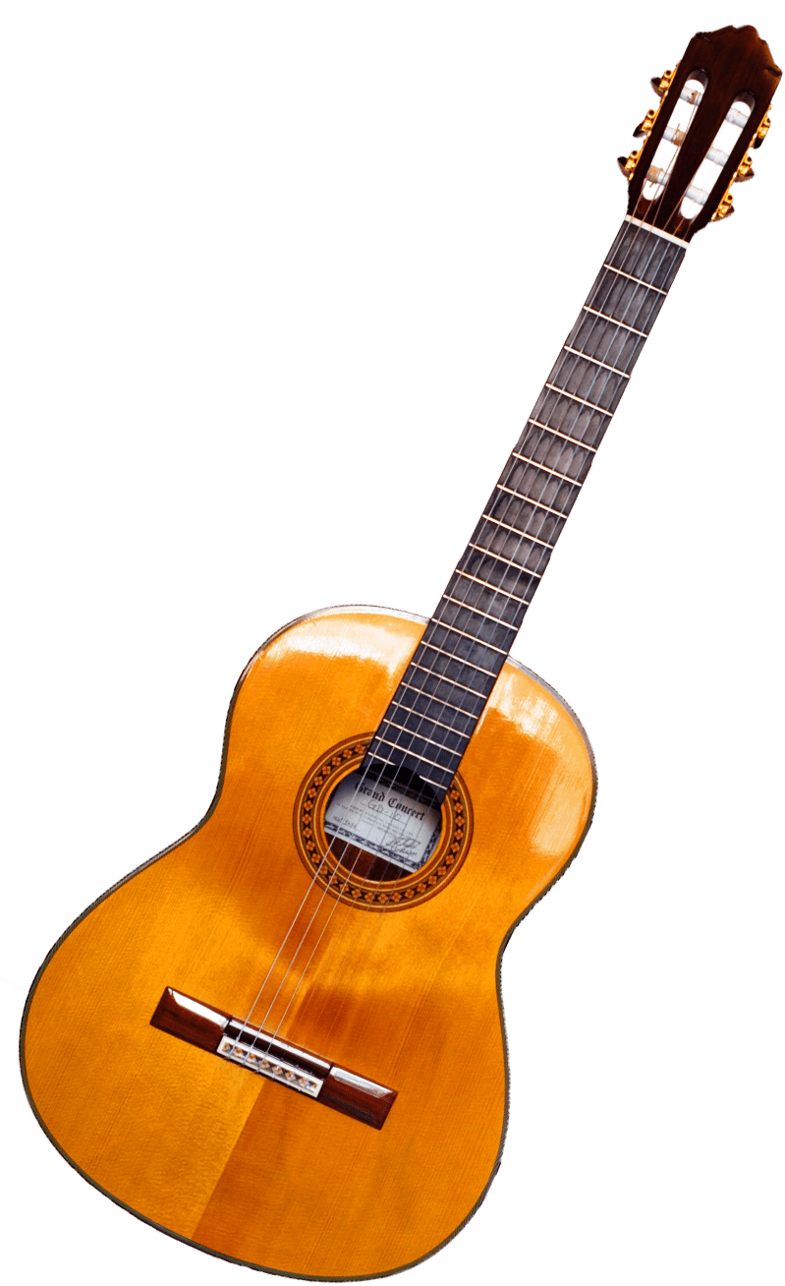
This Photo by Unknown Author is licensed under CC BY-NC

