Rights
Respecting
Policy

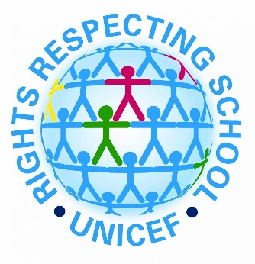
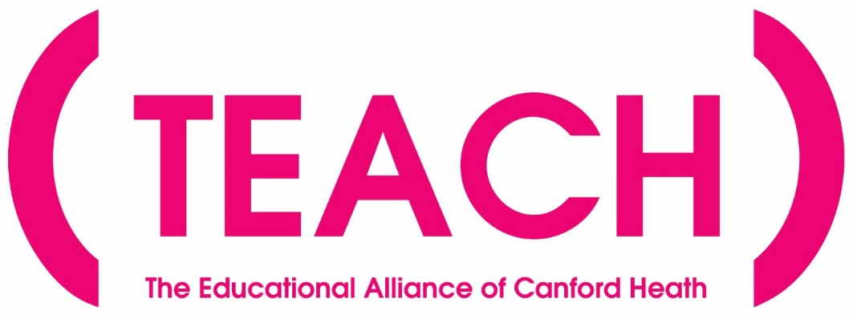

Statement of Intent
Our mission is to promote a love of learning in order to maximise the life chances of every child in our Trust. Through nurturing, high expectations and skilled teaching, we will have a lasting and positive impact on our local and wider community.
Our Vision
The TEACH Trust supports our children to become empowered citizens that make a meaningful contribution to society. Our curriculum reflects our locality and all it offers and aims to educate all children in matters which affect humanity in the wider world: these include all matters that relate to the climate and the world around us, such as climate change; the importance of respecting and celebrating the importance of equality and diversity; and being responsible global citizens.
We have the highest aspirations for our children: the broad and balanced curriculum promotes learning, provides cultural capital and supports spiritual, moral, social and cultural development. The Rights Respecting Gold awards and Anti Bullying awards reflect some of many ways in which education for character are integral to the work of our schools and highlights our focus on the children’s personal development.
We aim to inspire our children to be socially conscious individuals who make a difference to the world. All our children secure the key learning and skills they will need to become lifelong learners and gain employment. Our ultimate aim is to improve all our children’s life chances and prepare them to thrive in their future lives.
Under the Equality Act 2010 and the Public Sector Equality Act which came into force in April 2011, the Trust has due regard to the need to eliminate discrimination, advance equality of opportunity and foster good relations.

Rationale

Our vision for our children is that they become empowered global citizens who make a meaningful contribution to society and play their part in making the world a better place.
The aims of our school curriculum are as follows:

- to teach children about UNCRC convention so that they have a respect for themselves, high self-esteem and be able to live and work co-operatively with others
- to instil a love of reading through high quality literature that unlocks imagination, expands vocabulary and provides access to unlimited discovery
- to promote a positive attitude towards learning based on the Teach Trust values, so that children enjoy coming to school and acquire a solid basis for lifelong learning
- to teach children key skills and knowledge through a broad and balanced curriculum, that fulfils the requirements of the 2014 National Curriculum, to prepare them for the modern world
- to enable children to be creative and to develop their own thinking
- to teach children how they can safeguard and enhance their physical and mental well-being
- to advance children’s cultural capital to enable them to be positive citizens in their local, national and global community
- to teach children about their developing world, including how their environment and society have changed over time
- to help children understand the importance of truth and fairness, so that they grow up committed to eradicating prejudice and celebrating diversity.
- to promote the British values of democracy, the rule of law, equality, individual liberty and mutual respect for those with different faith and beliefs

Policy

All four TEACH trust schools are Gold Rights Respecting schools. Evidence shows that children who are aware of their rights make informed decisions and are more likely to grow into confident, active and responsible citizens. In addition, they can benefit from;

- Improved self-esteem and well –being
- Improved relationships and behaviour
- Improved engagement in learning
- Enhanced moral understanding and support for Global justice
- Positive attitudes towards diversity in society and reduction prejudice

As a Rights Respecting School, our philosophy is underpinned by the values and principles of the United Nations Convention on the Rights of the Child (UNCRC). This is a comprehensive human rights treaty that enshrines children’s rights. The CRC consists of 54 articles. A ‘child’ being defined as every human below the age of 18.

The Convention sets out the rights of children. These basic rights encompass survival, protection, development and participation.

The UNCRC is underpinned by four principles:

1. Non-discrimination

2. Commitment to the best interests of the child

3. The right to life, survival and development

4. Respect for the views of the child

The main responsibility for ensuring that all children enjoy their rights lies with adults (duty bearers). Rights are universal, inherent, indivisible, inalienable and unconditional.

What is a Rights’ Respecting school?

A Rights Respecting school will focus on:

- Teaching and Learning about rights: for the whole school community through training, curriculum, assemblies, topics, focus days/weeks, displays.
- Teaching and Learning through rights: by modelling rights respecting language and attitudes and making strategic decisions that involve students.
- Being ambassadors for the rights of others: developing as rights respecting citizens.

The role of the class teacher

- Model rights respecting language and behaviour
- Ensure the children can access their rights
- Ensure the children are respecting others with rights respecting behaviour
- Teaching the children about the UNCRC and its values.
- To promote pupil voice at all times

The role of school leaders

- To develop as a rights respecting school
- To ensure all decisions are taken in the best interests of children.
- As school policies are reviewed, to ensure links with the values and principles of the UNCRC will be made explicit
- To utilize pupil voice wherever possible to inform school improvement
- To support this policy and ensure it features regularly on agendas at staff meetings so that for all staff knowledge and understanding remains relevant.

The role of the subject leaders

- To ensure all staff are kept updated and informed on the development of our RR action plans and the work of the UNCRC
- Support staff with any RR training
- Promote children’s rights in the local community
- Support local schools on the work of the UNCRC
- To use pupil voice to continue the school’s RR journey
- To support pupils in their RR campaigns

The role of the Trustees

To support the school in its RR journey and ensure all policies, practice, planning and ethos has RR at its heart.

Equality Impact Assessment

Question | Response
Which relevant groups and  stakeholders have been consulted with in relation to this policy? |  | Please tick
 | Pupils | 
 | Trustees | 
 | Staff | 
 | Parents/Carers
 | Local Authority
 | Trade Unions
 | Other Advisors (give details)
What are the arrangements for  monitoring and reviewing the actual  impact of the policy? | Termly
 | Annually
 | When applied |   
 | If legislation changes
 | If a formal complaint

Does the policy affect one group less or more favourably than another on the basis of: | Y/N
Disability | N
Gender reassignment | N
Marriage or civil partnership | N
Pregnancy and maternity | N
Race | N
Religion or belief | N
Sexual orientation | N
Sex (gender) | N
Age | N
SEN | N
Vulnerable | N
Traveller, migrant, refugees and people seeking asylum | N
EAL | N

 | Y/N | Comments/Actions
Is there any evidence that some groups are affected differently? | N
If you have identified potential discrimination, are any exceptions valid, legal and/or justifiable? | N
Is the impact of the policy likely to be negative? | N
If yes, can the impact be mitigated by taking different action?

Reviewed September 2023

